Kubernetes Task-10
- Setup eks cluster using eksctl
- setup eks cluster using console
- Setup HPA
- Setup cluster autoscale
- Setup cronjob and job
- Create secret and inject inside pod
- Check differen add-ons available on eks.
- Upgrade eks cluster

a) Install Chocolatey (if not already installed): Open PowerShell as Administrator and run:
Set-ExecutionPolicy Bypass -Scope Process -Force; [System.Net.ServicePointManager]::SecurityProtocol = [System.Net.ServicePointManager]::SecurityProtocol -bor 3072; iex ((New-Object System.Net.WebClient).DownloadString('https://chocolatey.org/install.ps1'))

b) Install eksctl using Chocolatey:
choco install eksctl –y
Verify installation
After install completes, confirm:
eksctl version

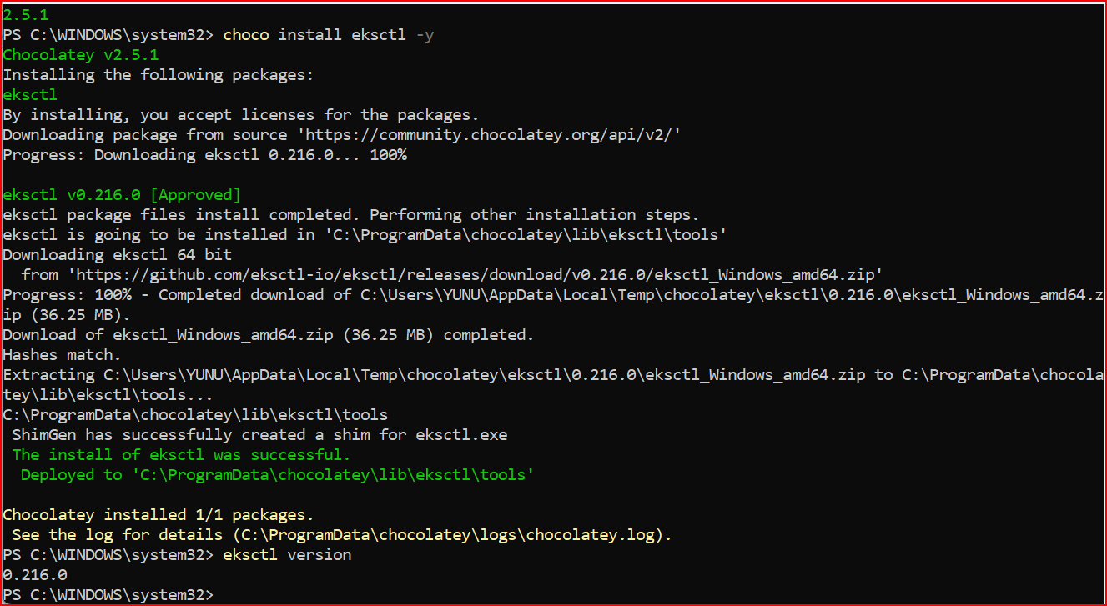

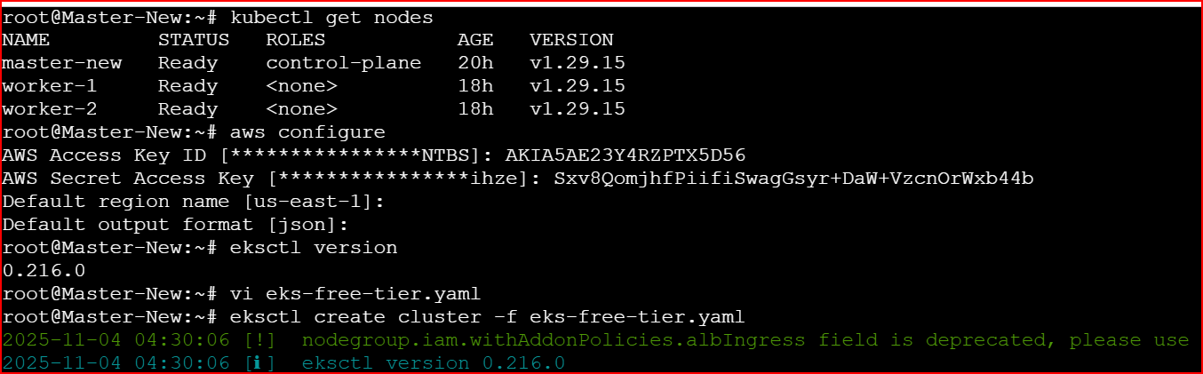

Setup EKS cluster using below yaml file:
filename: eks-free-tier.yaml
==============================
apiVersion: eksctl.io/v1alpha5
kind: ClusterConfig

metadata:
name: free-tier-eks
region: us-east-1
version: "1.28"

vpc:
clusterEndpoints:
publicAccess: true
privateAccess: false
publicAccessCidrs:
- 0.0.0.0/0 # Replace with your IP for security

nodeGroups:
- name: free-tier-nodes
instanceType: t3.small
desiredCapacity: 2
minSize: 2
maxSize: 3
volumeSize: 20
iam:
withAddonPolicies:
autoScaler: true
ebs: true
albIngress: true

Execute below command to create cluster:
eksctl create cluster -f eks-free-tier.yaml

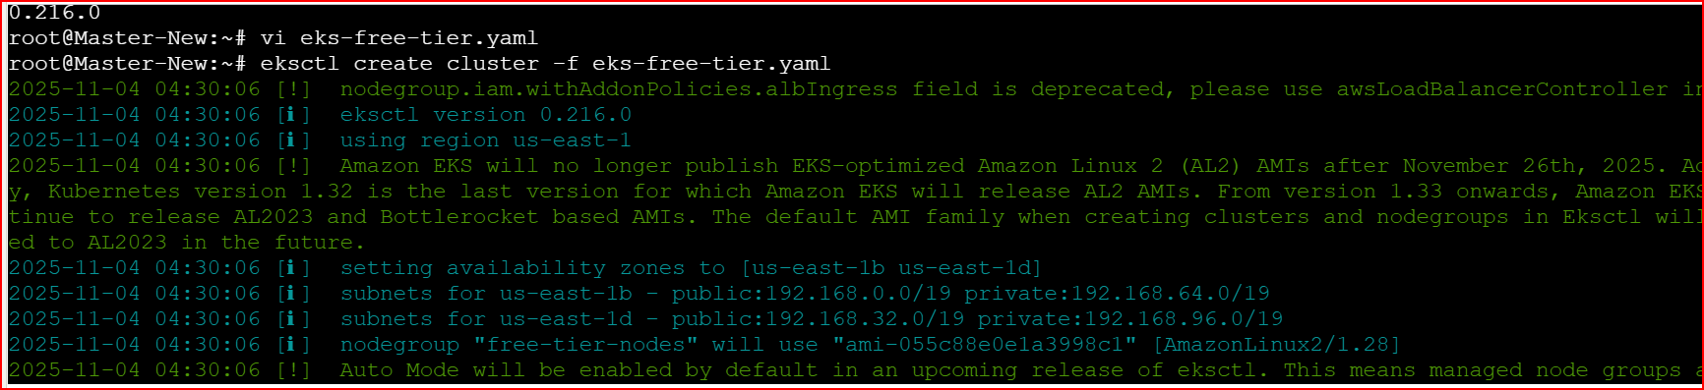

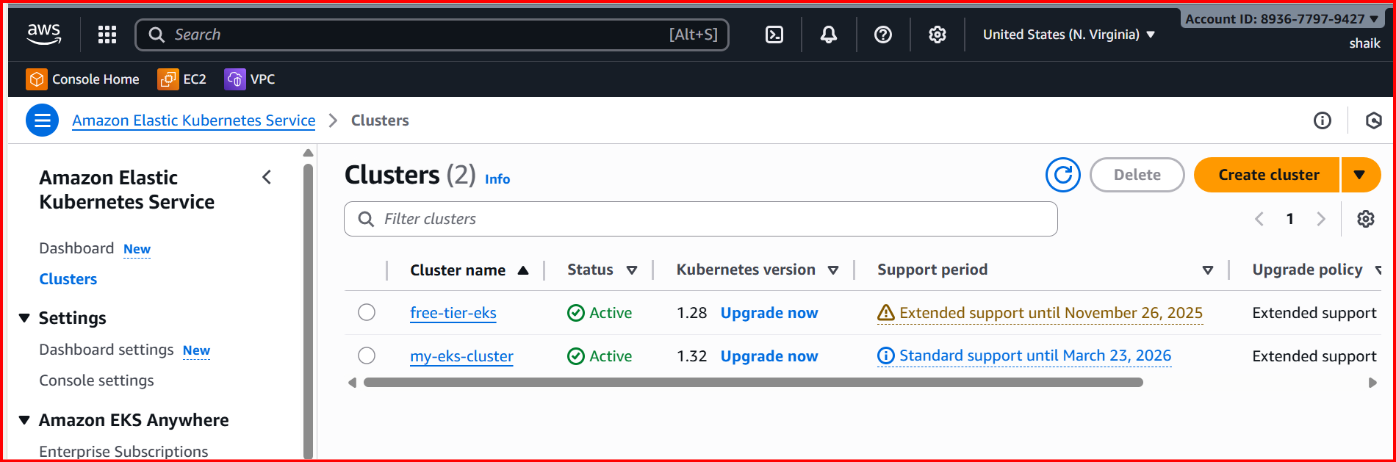

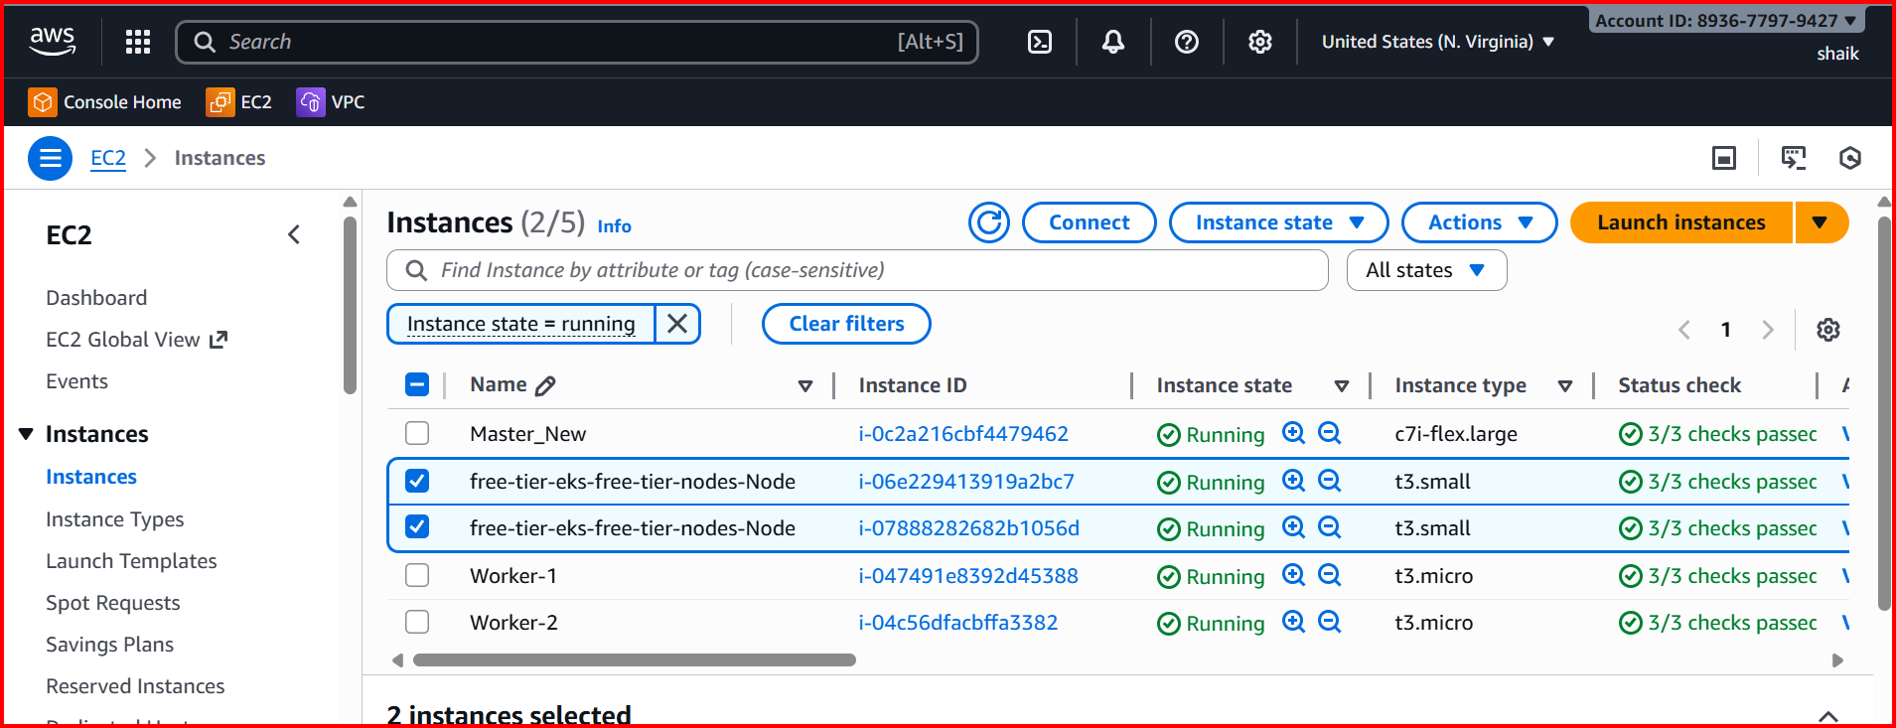

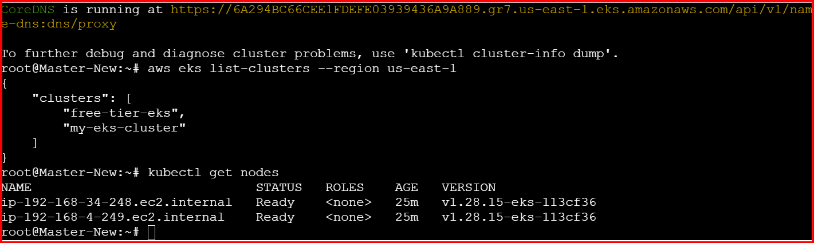
setup pod and assign hpa:

Vi nginx-deployment.yaml
apiVersion: apps/v1
kind: Deployment
metadata:
name: nginx-deployment
spec:
replicas: 1
selector:
matchLabels:
app: nginx
template:
metadata:
labels:
app: nginx
spec:
containers:
- name: nginx
image: nginx
resources:
requests:
cpu: 100m
limits:
cpu: 200m
ports:
- containerPort: 80
Kubectl apply -f nginx-deployment.yaml
Kubectl get pods -o wide
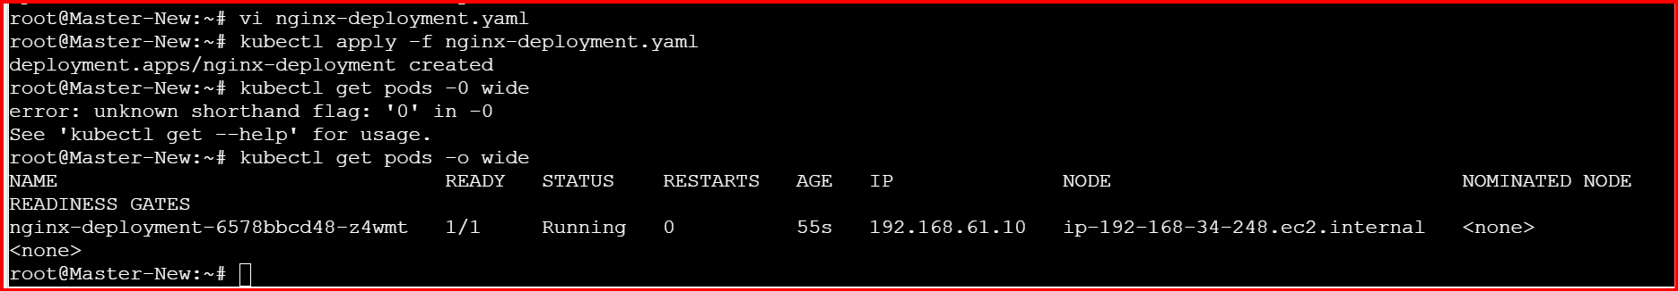
Kubectl get pods -n kube-system
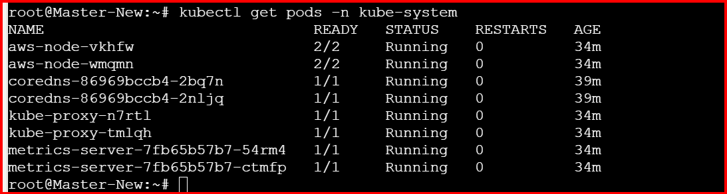
Setup hpa
Vi hpa.yaml
apiVersion: autoscaling/v2
kind: HorizontalPodAutoscaler
metadata:
name: nginx-hpa
spec:
scaleTargetRef:
apiVersion: apps/v1
kind: Deployment
name: nginx-deployment
minReplicas: 1
maxReplicas: 5
metrics:
- type: Resource
resource:
name: cpu
target:
type: Utilization
averageUtilization: 50

kubectl apply -f hpa.yaml

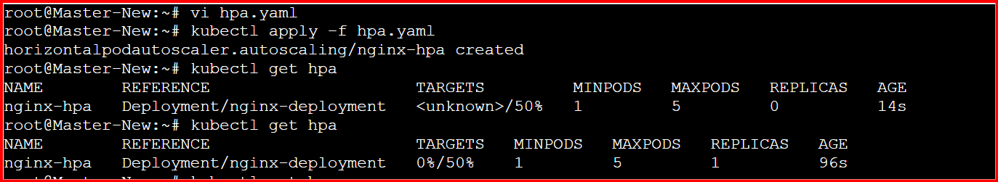
Kubectl get pods
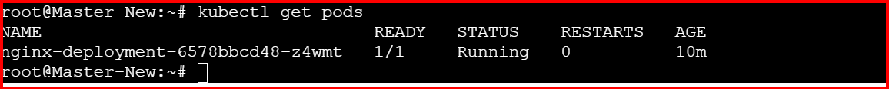

Create one service file:
Vi nginx-nodeport-service.yaml
apiVersion: v1
kind: Service
metadata:
name: nginx-service
spec:
type: NodePort
selector:
app: nginx # Make sure this matches your deployment labels
ports:
- port: 80
targetPort: 80
nodePort: 30080 # Must be between 30000–32767
kubectl apply -f nginx-nodeport-service.yaml
kubectl get services

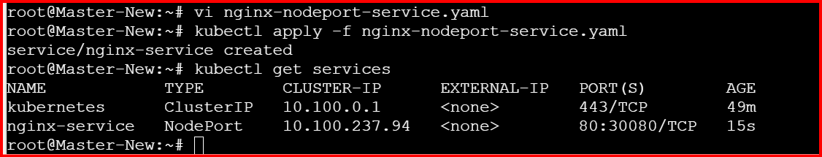

Vi load-generator.yaml
apiVersion: v1
kind: Pod
metadata:
name: load-generator
spec:
containers:
- name: busybox
image: busybox
command: ["/bin/sh"]
args: ["-c", "while true; do wget -q -O- http://nginx-service.default.svc.cluster.local; done"]

kubectl apply -f load-generator.yaml

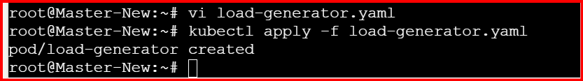

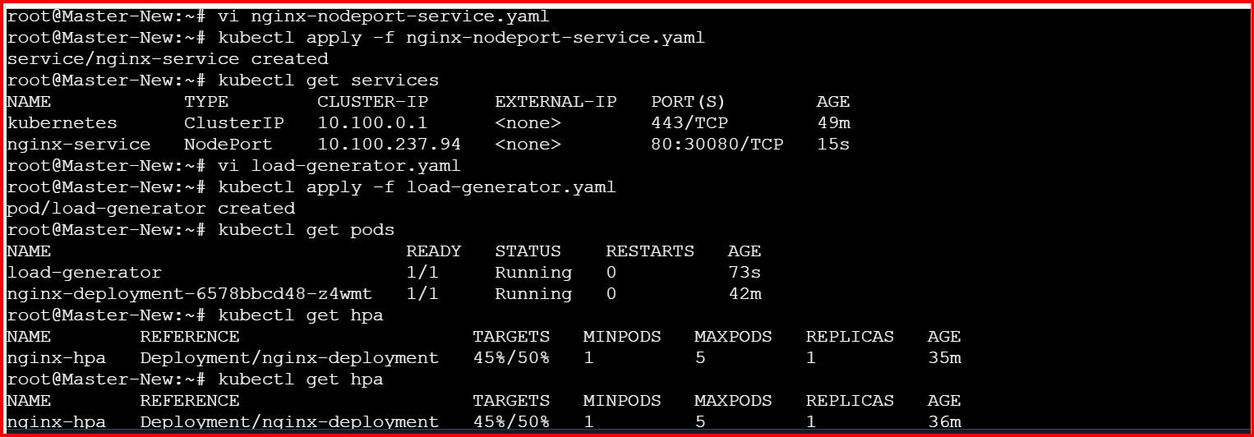

Load deleted then pods automatically reduce
Setup cluster autoscale
CLuster Autoscaler:

This will help you to scale number of worker nodes based on pending pods.
How to setup:

1) Get the name of autoscaling group.
# aws autoscaling describe-auto-scaling-groups --query "AutoScalingGroups[*].AutoScalingGroupName" --output table

2) update the tags with name and execute below command.
# aws autoscaling create-or-update-tags --tags \
ResourceId=<ASG_NAME>,ResourceType=auto-scaling-group,Key=k8s.io/cluster-autoscaler/enabled,Value=true,PropagateAtLaunch=true \
ResourceId=<ASG_NAME>,ResourceType=auto-scaling-group,Key=k8s.io/cluster-autoscaler/medium-eks-cluster,Value=owned,PropagateAtLaunch=true

1.create iam policy for cluster autoscaling.

Policy name: AmazonEKSClusterAutoscalerPolicy
{
"Version": "2012-10-17",
"Statement": [
{
"Effect": "Allow",
"Action": [
"ec2:DescribeInstances",
"ec2:DescribeInstanceTypes",
"ec2:DescribeRegions",
"ec2:DescribeAvailabilityZones",
"ec2:DescribeSpotPriceHistory",
"ec2:DescribeSecurityGroups",
"ec2:DescribeKeyPairs",
"ec2:RunInstances",
"ec2:TerminateInstances",
"ec2:DescribeInstanceStatus",
"ec2:DescribeLaunchTemplateVersions",
"ec2:DescribeLaunchTemplates",
"ec2:DescribeImages",
"ec2:CreateTags",
"ec2:DescribeTags",
"autoscaling:DescribeAutoScalingGroups",
"autoscaling:DescribeLaunchConfigurations",
"autoscaling:UpdateAutoScalingGroup",
"autoscaling:DescribeScalingActivities",
"autoscaling:DescribeTags",
"autoscaling:SetDesiredCapacity",
"autoscaling:TerminateInstanceInAutoScalingGroup"
],
"Resource": "*"
}
]
}

2.Create a policy Aws Console
Select json

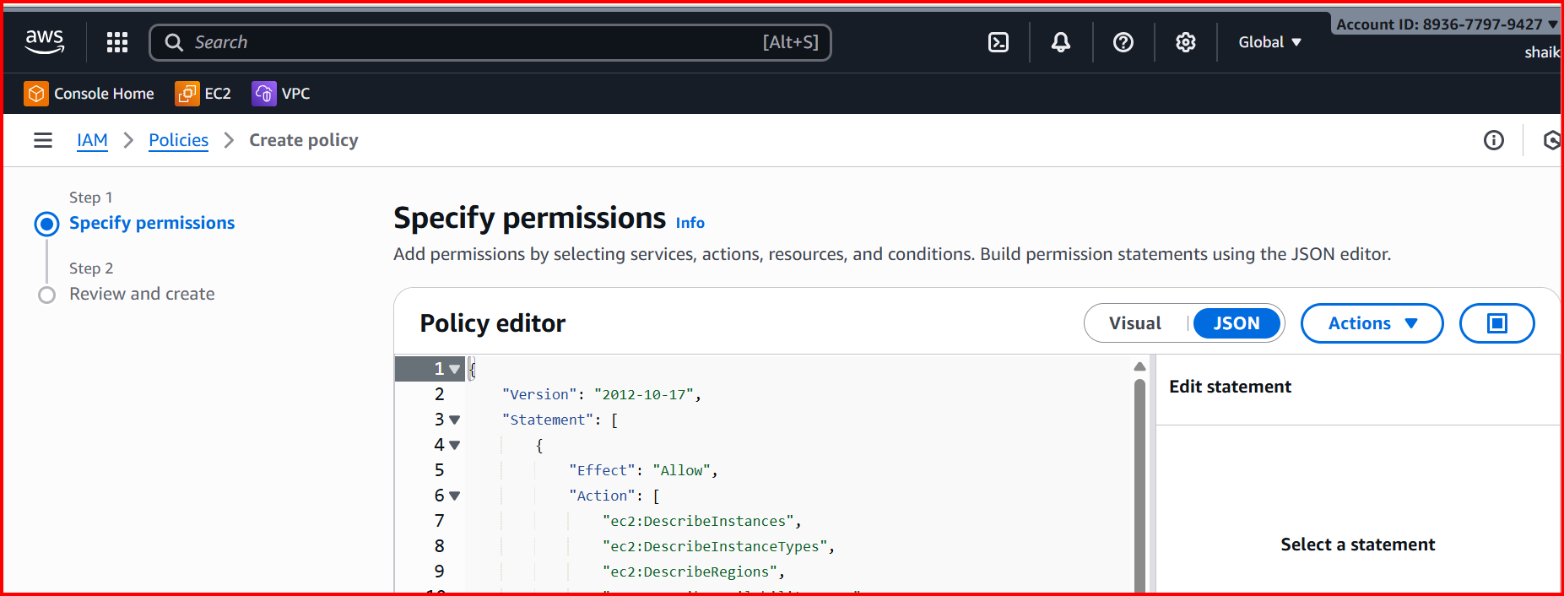

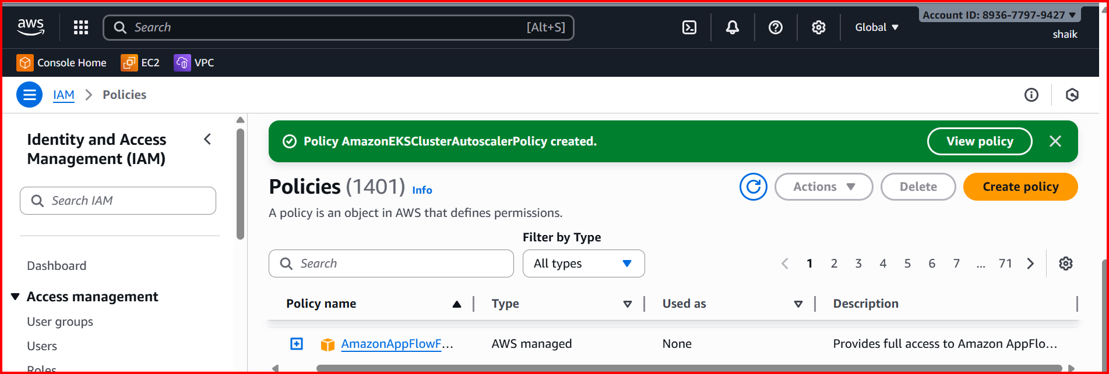

3.setup IAM Service Account for Cluster Autoscaler

eksctl create iamserviceaccount \
--cluster <your-cluster-name> \
--namespace kube-system \
--name cluster-autoscaler \
--attach-policy-arn arn:aws:iam::<AWS_ACCOUNT_ID>:policy/AmazonEKSClusterAutoscalerPolicy \
--approve

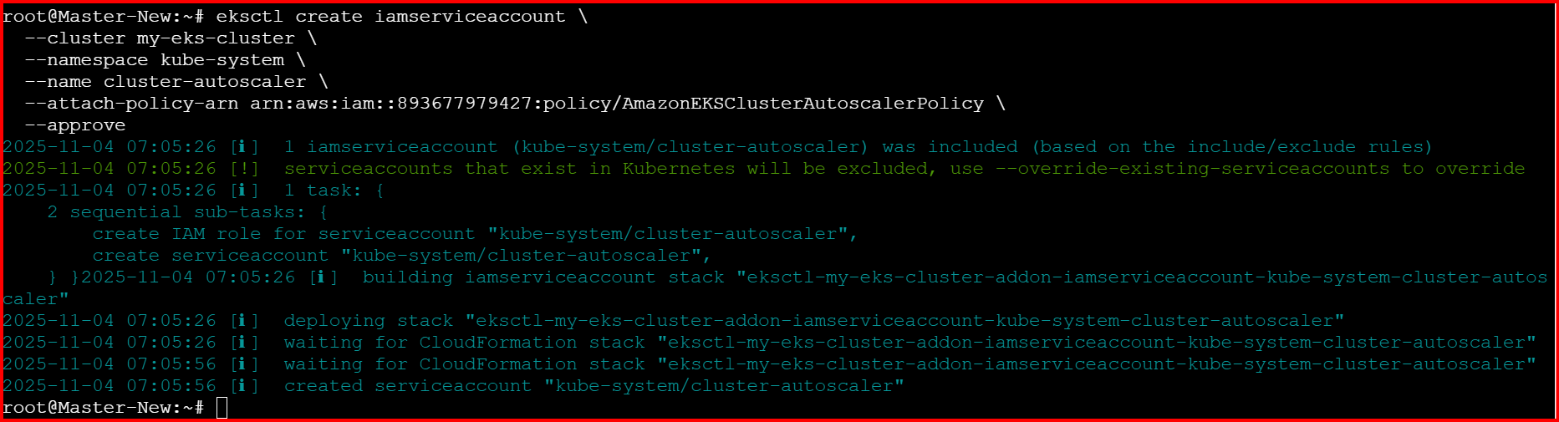

4.Install Cluster Autoscaler in the EKS Cluster

kubectl apply -f https://raw.githubusercontent.com/kubernetes/autoscaler/cluster-autoscaler-1.29.0/cluster-autoscaler/cloudprovider/aws/examples/cluster-autoscaler-autodiscover.yaml

kubectl get pods -n kube-system

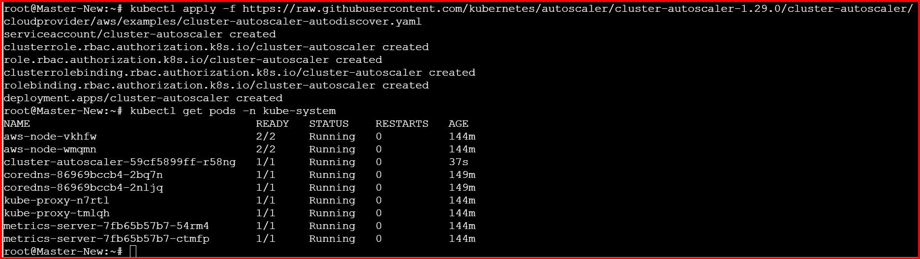

5. Once the Cluster Autoscaler is deployed, you'll need to patch the deployment to ensure it's properly configured with your cluster name and the right settings.

kubectl -n kube-system edit deployment.apps/cluster-autoscaler

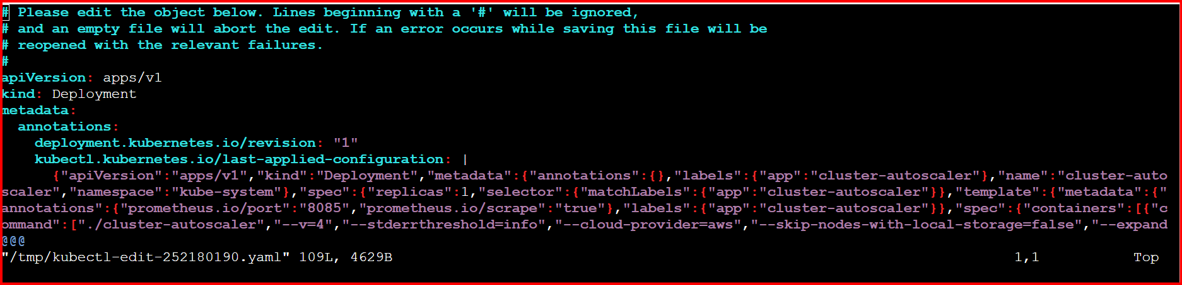
6) Verify the Deployment by checking logs.

kubectl -n kube-system logs deployment/cluster-autoscaler
7) Test the Autoscaler by Creating a High Resource Demand

Create a test deployment with name test-deployment.yaml

apiVersion: apps/v1
kind: Deployment
metadata:
name: test-deployment
spec:
replicas: 5
selector:
matchLabels:
app: test
template:
metadata:
labels:
app: test
spec:
containers:
- name: test-container
image: nginx
resources:
requests:
cpu: "500m"
memory: "512Mi"

Kubectl apply -f test-deployment.yaml

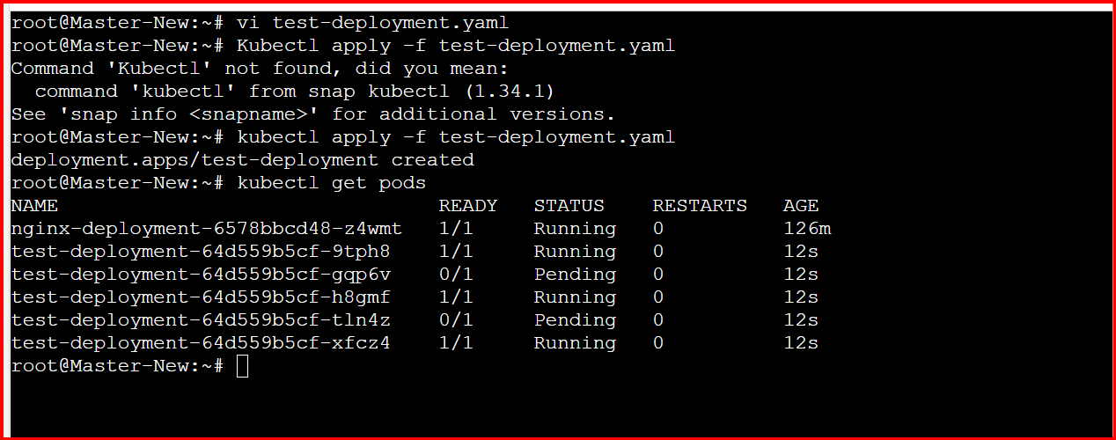

Setup cronjob and job
THis wil help you to execute a job based on schedule
How to setup:
Create one cronjob.yaml

Vi cronjob.yaml
apiVersion: batch/v1
kind: CronJob
metadata:
name: test-cronjob
namespace: default
spec:
# Cron schedule: “* * * * *” = every minute
schedule: "*/1 * * * *"
# Optional: limit number of successful/failed history
successfulJobsHistoryLimit: 3
failedJobsHistoryLimit: 1
jobTemplate:
spec:
template:
spec:
restartPolicy: OnFailure
containers:
- name: date-printer
# Lightweight image that has “date”
image: busybox:1.35
args:
- /bin/sh
- -c
- date; echo "Hello from EKS CronJob"

Run cronjob: kubectl apply -f cronjob.yaml
How to test: kubectl get cronjob

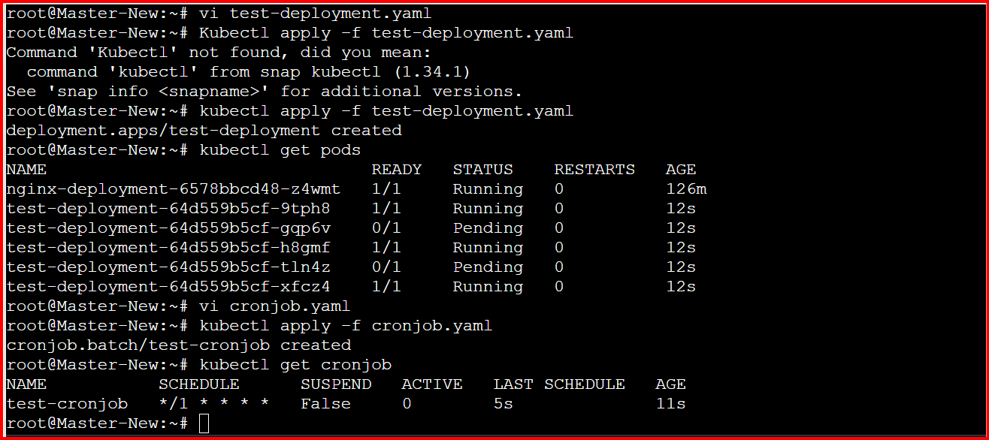

Create secret and inject inside pod
Create secret with name db-credentials in secret manager service.

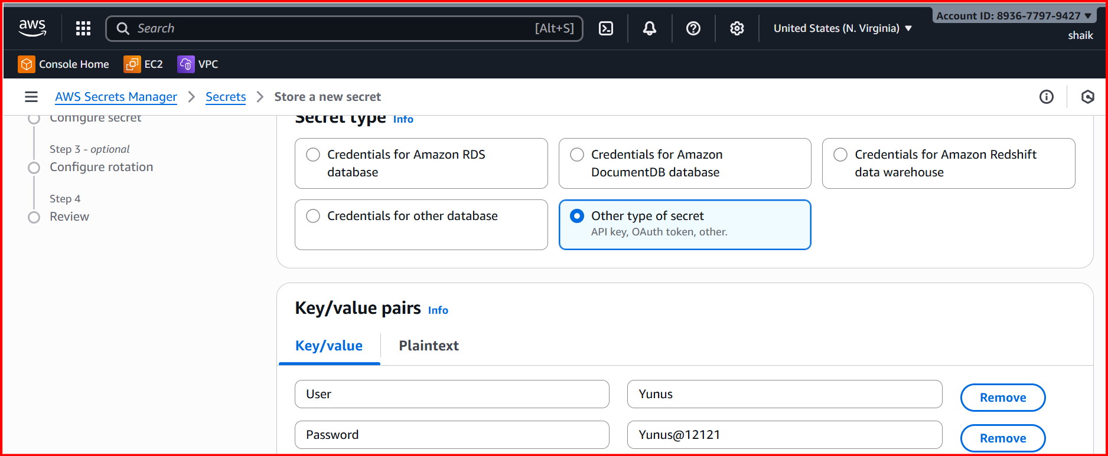
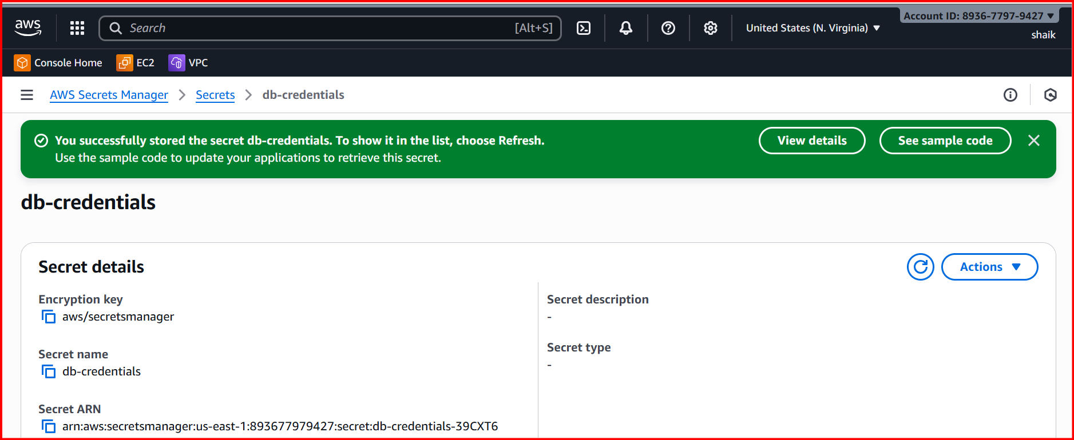
Enable OIDC (Open id connect) Provider for EKS.

OIDC will help us to check the token provided for eks to trust the identity of pod.

create OIDC connector for cluster using ekstl.

eksctl utils associate-iam-oidc-provider \
--region <your-region> \
--cluster <your-cluster-name> \
--approve

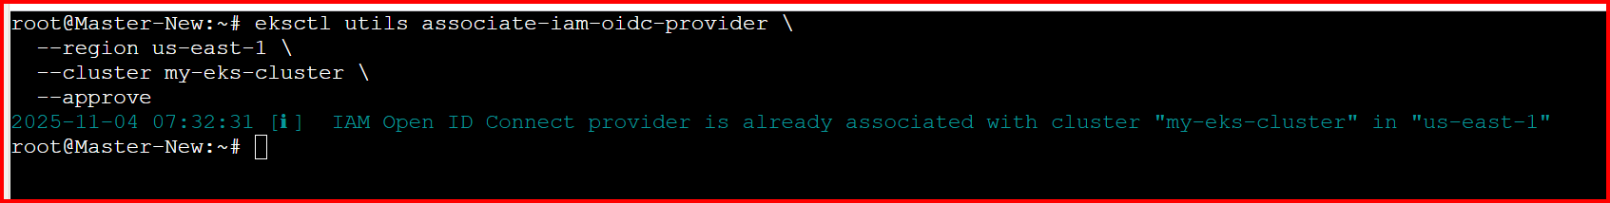

aws eks describe-cluster --name free-tier-eks --region us-east-1 --query "cluster.identity.oidc.issuer" --output text
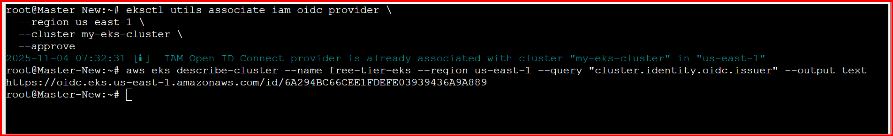

Create iam policy using below json template.

{
"Version": "2012-10-17",
"Statement": [{
"Effect": "Allow",
"Action": ["secretsmanager:GetSecretValue"],
"Resource": "arn:aws:secretsmanager:us-east-1:915992498174:secret:db-credentials*"
}]
}

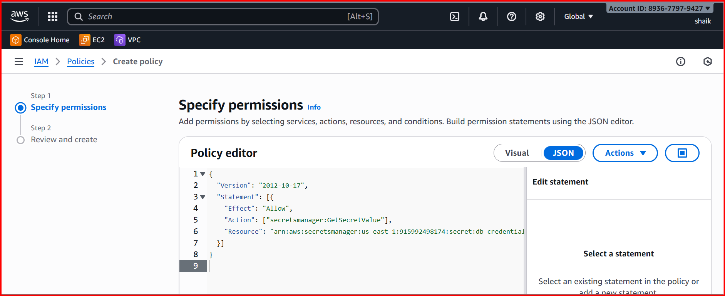

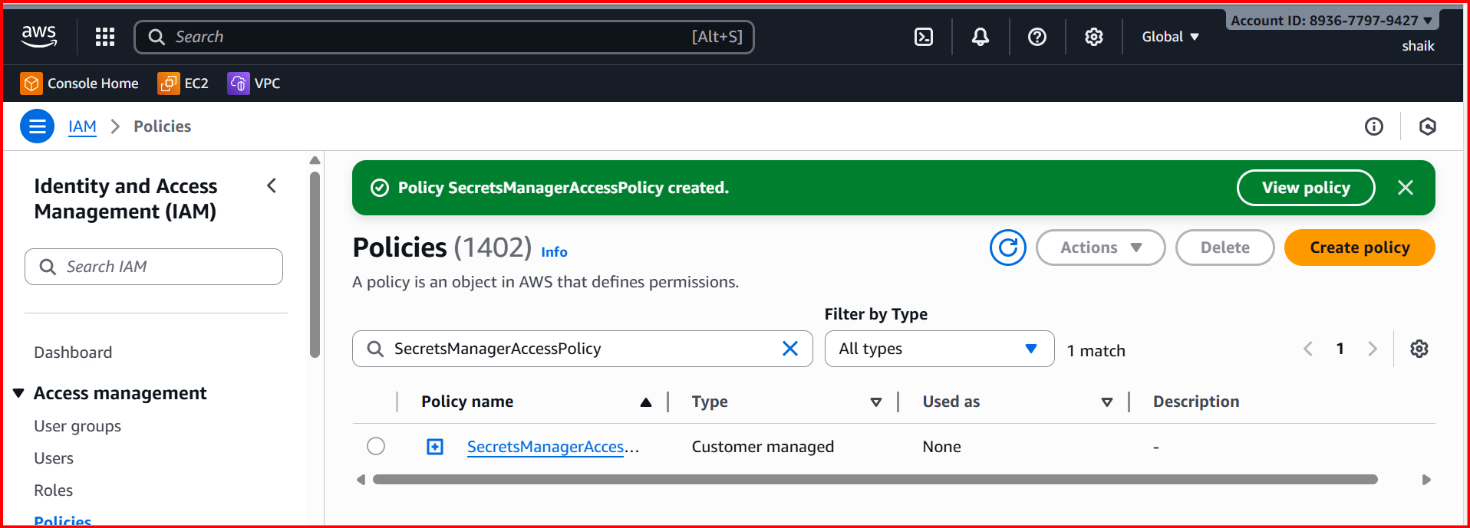

Create one role with custom trust policy using below json format and attach the policy created in step 4.

{
"Version": "2012-10-17" ,
"Statement": [{
"Effect": "Allow",
"Principal": {
"Federated": "arn:aws:iam::989496899013:oidc-provider/oidc.eks.us-east-1.amazonaws.com/id/F0CEF646FD8DE36F00D2AFE2C9985F3B"
},
"Action": "sts:AssumeRoleWithWebIdentity",
"Condition": {
"StringEquals": {
"oidc.eks.us-east-1.amazonaws.com/id/F0CEF646FD8DE36F00D2AFE2C9985F3B:sub": "system:serviceaccount:default:secrets-sa"
}
}
}]
}

A Service Account is like an identity card for your pods, allowing them to
access the Kubernetes API and AWS services securely,
based on the permissions they are granted.

7)Deploy pod using service account.
deployment.yaml
###############
apiVersion: apps/v1
kind: Deployment
metadata:
name: secret-app
spec:
replicas: 1
selector:
matchLabels:
app: secret-app
template:
metadata:
labels:
app: secret-app
spec:
serviceAccountName: secrets-sa
containers:
- name: app
image: amazonlinux
command: [ "/bin/sh", "-c" ]
args:
- "yum install -y aws-cli jq; \
aws secretsmanager get-secret-value --secret-id db-credentials --region us-east-1 | jq .SecretString"

Create deployment: kubectl apply -f deployment.yaml

